BARE OR COVERED?
This is an ambiguous phrase that calls to mind many scenarios; the good, bad and ugly…. making one wonder exactly what is meant or was meant by its user. In the case of Akua Blessing, a form one student of Amanchia District Authority Junior High School in the Atwima Nwabiagya district of the Ashanti region in Ghana, it concerned a pair of rubber sandals, a pair of torn leather sandals and her bare feet.
On the 27TH May, 2016 during delivery of orange seedlings to the WHW Girls Club, I saw that all club members as well as students of Amanchia D/A were neatly dressed in clean uniforms, white socks and sandals. One student stood out! She was dressed in a clean and well-ironed uniform, with her hair combed neatly BUT had no shoes. Class mates giggled and teased as they passed by her while others smiled and patted her arm or shoulder in sympathy.
Akua Blessing without her sandals. Photo courtesy WHW
Upon enquiry, it was revealed that, Blessing had worn black flip flops locally referred to as Charlie Wote to school that morning, because her only pair of well-worn sandals had come apart the previous night before while cleaning it for school. However, it is against the school regulations to wear Charlie wote to school and the pair of flip flops had been seized in accordance with the school rule and poor Akua now had to go barefoot as she had no acceptable foot wear to put on even if she went back home.
Akua lost her Charlie wote and had to bear the shame and humiliation of walking barefoot on the rough stony compound and being tagged as a disobedient student.
Fortunately for Akua, WHW provided a new pair of approved sandals and so she did not have to go through the humiliation of walking barefoot for days, weeks or even months on end.

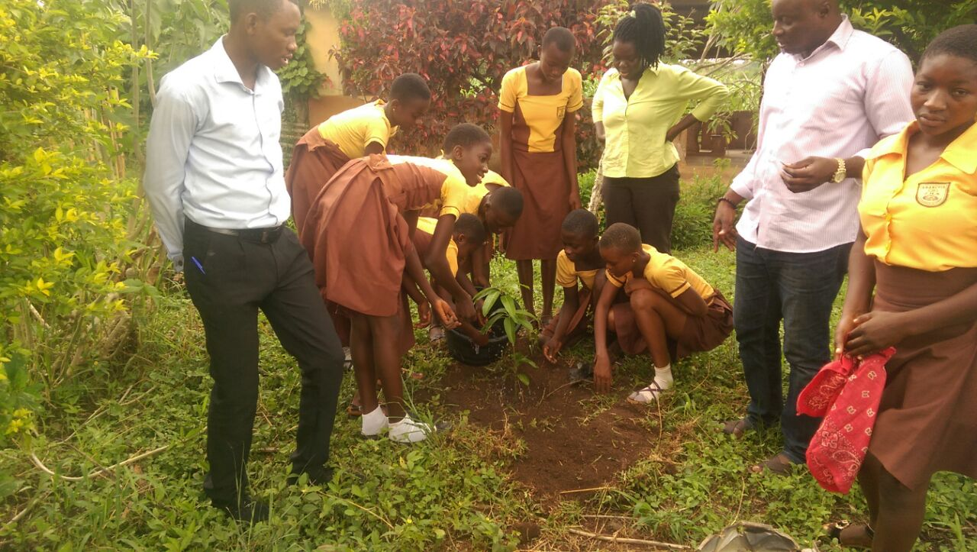 Akua Blessing (arrowed) participating in tree planting after being provided with new sandals Photo courtesy WHW

Food for thought
Knowing full well the implications of her actions that fateful morning as Akua set off to school, her desire for an education with a better future at all costs, made her do the unthinkable….
One cannot help but wonder,
- How many more Akua Blessings are in communities outside the operational areas of WHW?
- How long can these young ladies keep up with the taunts of their peers and community members for lack of one need or the other in seeking to make a better future for themselves and posterity through education?

